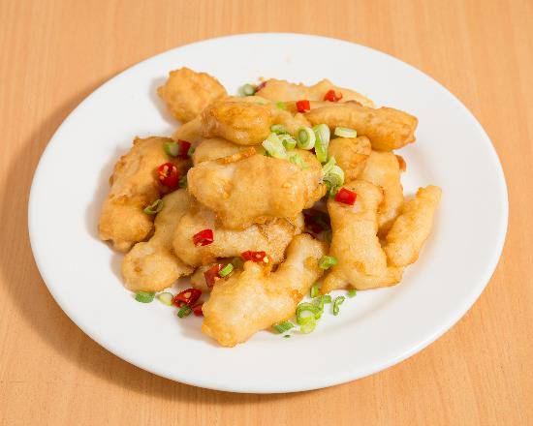  Salt & Pepper Fish  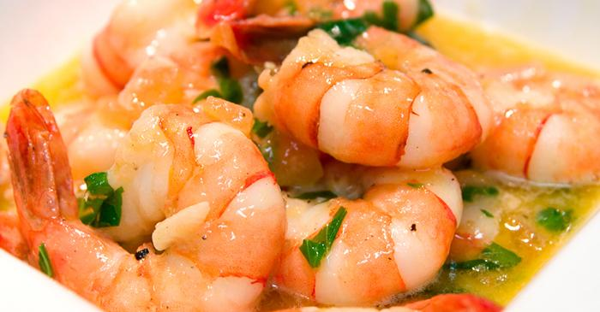  Garlic Butter Prawns  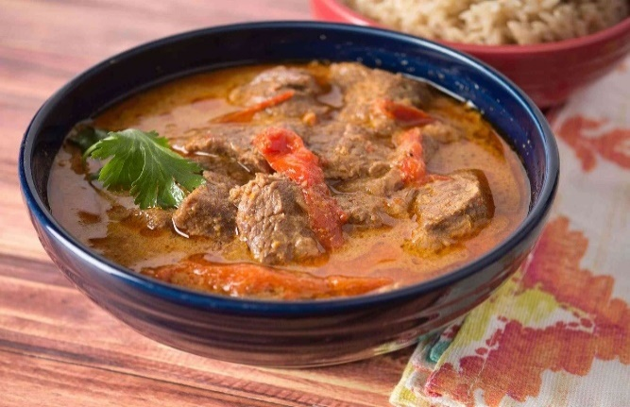  Thai Red Beef Curry  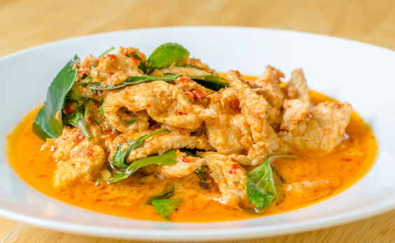  Thai Panang Chicken Curry  Pictures are for reference only | 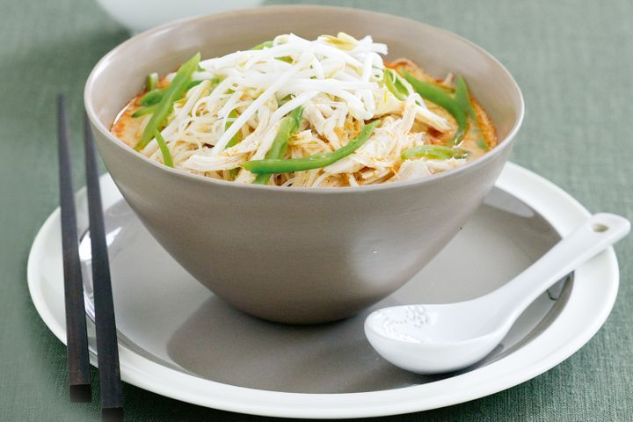  Chicken Laksa  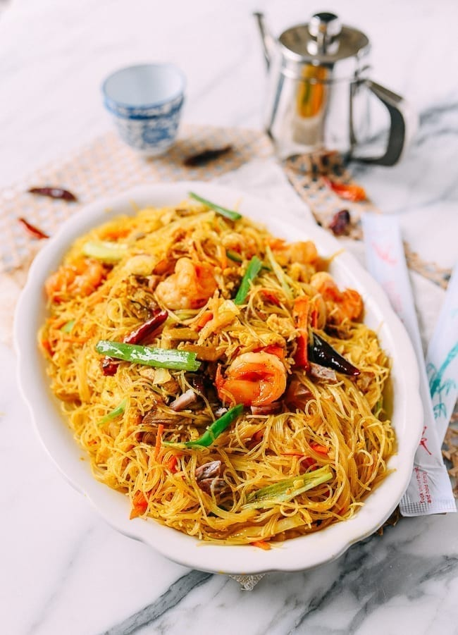  Singapore Noodles  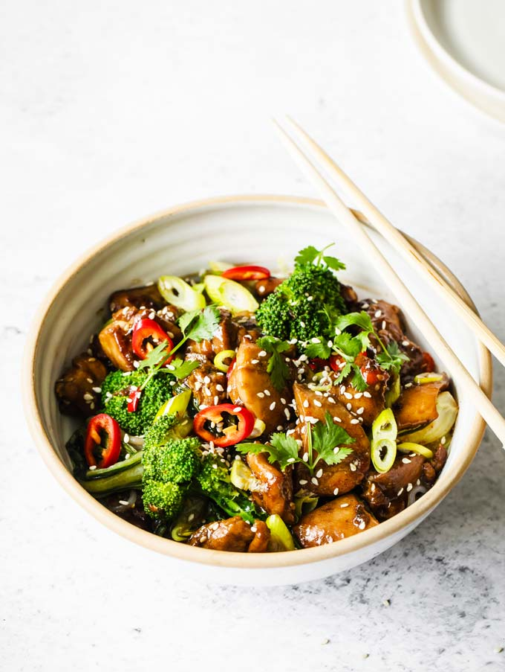  Teriyaki Beef  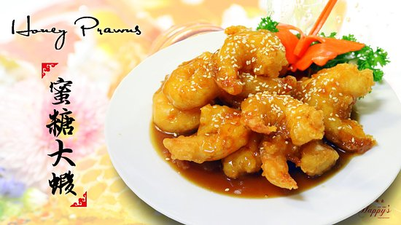  Honey Prawns | M&J KITCHEN  Chinese Cuisine  Wilcannia Golf Club  25-29 Ross St, Wilcannia NSW 2836   (08) 8091 5943  Business Hours  Sunday Closed  Monday Morning Closed  Lunch Tue to Sat 12.00 pm - 2.00 pm  Dinner Mon to Sat 6.00 pm - 8.30 pm  LAST ORDER 8.30pm CASH ONLY  * Please advise any food allergies at time of ordering  * Restaurant will CLOSE EARLY if it’s a Slow night  * Prices are subject to change without notice
ENTREES  Mini Spring Rolls (4)  Steamed Dim Sims (4)  Fried Dim Sims (4)  Chicken Wings (6)  SOUP  Short Soup  Chicken Laksa  Prawns Laksa  Combination Short Soup  SEAFOOD  Salt & Pepper Fish  Salt & Pepper Squid  Garlic, Butter Prawns  Honey Black Pepper Prawns  CHICKEN  Lemon Chicken  Honey Chicken  Chicken & Cashews  Sichuan Chicken  Kung Pao Chicken  Satay Chicken  (Contain Peanuts)  Garlic Chicken  Mongolian Chicken(Contain Peanuts)  Chicken & Black Beans Sauce  Chicken & Oyster Sauce | $10.00  $10.00  $10.00  $10.00  $9.00  $21.00  $24.00  $25.00  $22.00  $24.00  $43.00  $43.00  $23.00  $23.00  $23.00  $21.00  $21.00  $21.00  $21.00  $21.00  $21.00  $21.00 | BEEF  Satay Beef (Contain Peanuts)  Sichuan Beef  Kung Pao Beef  Garlic Beef  Mongolian Beef (Contain Peanuts)  Beef & Black Bean Sauce  Beef & Oyster Sauce  Beef & Cashews  PRAWNS  Satay Prawns (Contain Peanuts)  Sichuan Prawns  Kung Pao Prawns  Salt & Pepper Prawns  Garlic Prawns  Honey Prawns  Mongolian Prawns (Contain Peanuts)  Prawns & Oyster Sauce  Prawns & Black Bean Sauce  Prawns & Cashews  THAI  Panang Vegetables  Panang Chicken Curry  Panang Beef Curry  Panang Combination Curry  Panang Prawns Curry  Green Chicken Curry  Green Beef Curry  Green Prawns Curry  Red Chicken Curry  Red Beef Curry  Red Prawns Curry | $21.00  $21.00  $21.00  $21.00  $21.00  $21.00  $21.00  $23.00  $41.00  $41.00  $41.00  $41.00  $41.00  $41.00  $41.00  $41.00  $41.00  $43.00  $18.00  $21.00  $21.00  $27.00  $41.00  $21.00  $21.00  $41.00  $21.00  $21.00  $41.00 | SWEET & SOUR  Sweet & Sour Chicken  Sweet & Sour Pork  Sweet & Sour Combination  Sweet & Sour Prawns  CHOW MEIN  (Crispy Noodles)  Vegetable Chow Mein  Beef Chow Mein  Chicken Chow Mein  Singapore Noodles  Combination Chow Mein  Prawns Chow Mein  COMBINATION  Satay Combination (Contain Peanuts)  Sichuan Combination  Kung Pao Combination  Mongolian combination (Contain Peanuts)  Garlic Combination  Combination & Oyster Sauce  Combination & Black Bean Sauce  Combination & Cashews  VEGETABLES  Vegetables & Oyster Sauce  Vegetables & Satay Sauce  Vegetables & Garlic Sauce  Vegetables & Cashews  (Satay contain Peanuts ) | $21.00  $23.00  $27.00  $41.00  $19.00  $22.00  $22.00  $22.00  $28.00  $42.00  $27.00  $27.00  $27.00  $27.00  $27.00  $27.00  $27.00  $29.00  $18.00  $18.00  $18.00  $20.00 | TERYAKI  (Sweet Soy Sauce)  Chicken  Beef  Combination  Prawns  RICE  Small Boiled Rice  Large Boiled Rice  Small Fried Rice  Large Fried Rice  Small Special Fried Rice  Large Special Fried Rice  AUSSIE MEALS  Hot Chips | $21.00  $21.00  $27.00  $41.00  $7.00  $9.00  $10.00  $12.00  $12.00  $14.00  $8.00
(Any Special Requests or Add On will be extra charge)

